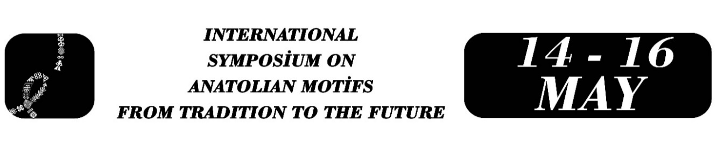

The Use of Anatolian Motifs in the Context of the Culture Industry: The Case of Paşabahçe

Abdulkadir Önkol
Abstract
The industrialization of culture is seen as a result of the Industrial Revolution that occurred in the West in the 19th century. The concept of the culture industry was used by Theodor W. Adorno and Max Horkheimer in 1947. In this period, a negative meaning was attributed to the culture industry through concepts such as consumption, mass, and commodity. Towards the end of the 20th century, as a result of the changing cultural, economic, and social structure, culture began to be seen as a resource. Instead of the negative meanings attributed to the industrialization of culture, its characteristics such as creativity and development have been emphasized, stating that this economic resource is an important tool for the survival and transmission of cultures. Recent studies carried out under the umbrella of United Nations Educational, Scientific and Cultural Organization also show that the economic and commercial dimension of culture is important for local cultures. This study aims to analyze the traditional motifs used by the Paşabahçe brand in its products in the context of the culture industry, creativity, and applied folklore. Paşabahçe stores' online sales page and catalogs were examined through qualitative document analysis, and the findings were interpreted using descriptive content analysis. It has been determined that Paşabahçe products include many motifs ranging from architecture to mythology. The reasons for choosing the Paşabahçe brand for the study include its continuous retail activities in the glass sector for 70 years, the creation of 17 boutique collections in total since its first boutique collection, the Ottoman Collection, in 1999, and the delivery of these products to 43 countries outside of Turkey by including motifs belonging to Turkish culture in these collections. The motifs Paşabahçe has used in its collection products are important for the promotion of Anatolian culture and values, and it has been seen that they have the potential to be used as an element of Turkey's soft power in the international arena. It has been determined that creativity stands out in the designs of the motifs. However, it has been observed that the texts prepared for the promotion of the products are mostly informative. Therefore, it can be said that these texts are not sufficient for the marketing of culture. One of the most important marketing techniques today is the marketing of cultural codes and images through stories. The ties of the motifs used in these products with texts such as legends and mythology should be strengthened, and the promotional texts of the products should be reconstructed from this perspective. In addition, the opinions of folklorists should be utilized when creating these designs and texts, which are important in terms of applied folklore studies.
Keywords: Applied folklore, Culture industry, Anatolia, Paşabahçe, Handicrafts.

Assist. Prof. Dr. Abdulkadir ÖNKOL, Kahramanmaraş Sütçü İmam University, Department of Turkish Language and Literature, abdulkadironkol@ksu.edu.tr

