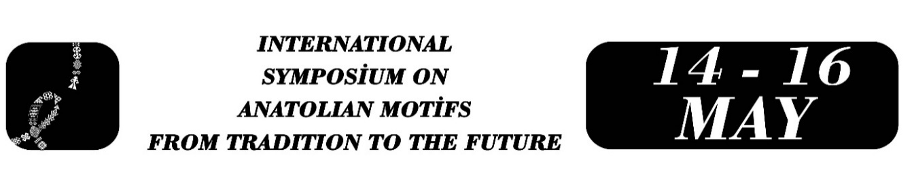

Reinterpretation of the Tree of Life Motif in Contemporary Jewelry Art within Anatolian Culture: Meaning, Continuity, and Formal Transformation
Nesrin Yeşilmen, Sevde Baran,Sevcan Baran
Nursel Gümüş, Şehnaz Tülan
Abstract
The Tree of Life motif is a deeply rooted symbolic image associated with concepts such as life, fertility, continuity, protection, and rebirth, and it appears across diverse cultures and historical periods. Within Anatolian culture, this motif has sustained its presence over time by acquiring new formal and symbolic layers through changing belief systems, aesthetic approaches, and modes of production. This study examines the historical and symbolic trajectory of the Tree of Life motif in Anatolian culture and focuses on how it may be reinterpreted within the context of contemporary jewelry art. In this framework, the origin of the motif, its semantic range, its formal evolution over time, and its representations across different communities will be explored. In addition, its use in various artistic disciplines—such as painting, architecture, sculpture, and traditional arts—will be evaluated through selected examples.The study is structured as a practice-based qualitative research project grounded in an artistic research approach that considers knowledge production through the processes of design and making. In the theoretical phase of the research, the cultural and formal continuity of the Tree of Life motif will be analyzed through a review of the relevant literature and the examination of visual examples. In the practical phase, five researchers, working from a shared theoretical framework, will reinterpret the Tree of Life motif within contemporary jewelry art through individual perspectives, each producing an original design. These designs will then be comparatively evaluated in terms of symbolic reference, formal transformation, material use, and modes of personal expression. The study is expected to demonstrate that the Tree of Life motif is not merely a historical decorative element, but rather a vital visual source that can be re-signified within contemporary jewelry art and can generate diverse formal possibilities. In this respect, the research aims to offer a practice-based contribution to current discussions on how Anatolian cultural heritage may be transformed within contemporary jewelry practice, while also highlighting the productive potential of traditional motifs in contemporary art and design.
Keywords: Tree Of Life Motif, Anatolian Culture, Contemporary Jewelry Art, Formal Transformation, Artistic Research.

Assoc. Prof. Dr. Nesrin Yeşilmen, Mardin Artuklu University, Midyat Faculty of Art and Design, Department of Metalcraft and Jewelry Design, nesrinyesilmen@gmail.com.
Undergraduate Student Sevde Baran, Mardin Artuklu University, Midyat Faculty of Art and Design, Department of Metalcraft and Jewelry Design, baransevda724@gmail.com.
Undergraduate Student Sevcan Baran, Mardin Artuklu University, Midyat Faculty of Art and Design, Department of Metalcraft and Jewelry Design, baransevcan61@gmail.com.
Undergraduate Student Nursel Gümüş, Mardin Artuklu University, Midyat Faculty of Art and Design, Department of Metalcraft and Jewelry Design, gumusnursel08@gmail.com.
Undergraduate Student Şehnaz Tülan, Mardin Artuklu University, Midyat Faculty of Art and Design, Department of Metalcraft and Jewelry Design, sehnaz4718@gmail.com.

