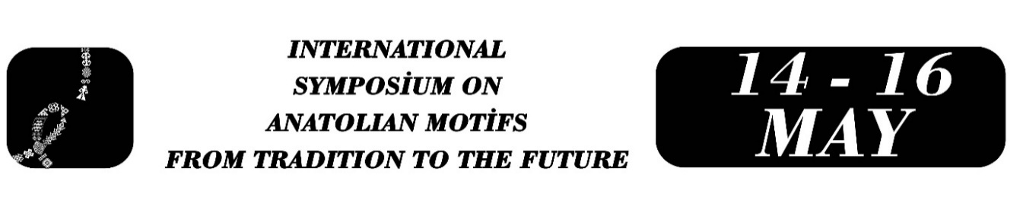

The Language and Social Meanings of “Kahramanmaraş Aba” Motifs
Ayşegül Kirişci
Furkan Köksöken
Abstract
Anatolian weaving tradition is not solely a production area that meets the needs of clothing and heating, but also forms a multi-layered field of expression reflecting social structure, economic status, belief system and cultural memory through motifs. “Kahramanmaraş Aba”, one of the unique examples of this weaving tradition, holds a significant place within the Anatolian motif tradition with its rich motif treasure and with its world of denotations supporting the “Weaving Atlas” project.
This research aims to examine the motifs of the “Kahramanmaraş Aba” within the context of the Anatolian motif tradition, considering their historical, technical, and symbolic aspects. Within the scope of the research, it has been revealed how the geometric motifs and plant motifs commonly used in “Aba” weaving, functioning not only as decorative elements but also as indicators reflecting the social status, economic potential, and social status of the wearer. Evaluations made especially on specific motif types such as sandık, gerdan, gül, and selvi that “Aba” weaving builds up a symbolic motif “language”.
The research was supported by field research and applied studies in addition to the literature review. In this respect, the “Aba” weaving practices conducted within the Kahramanmaraş Olgunlaşma Enstitüsü, the living artisans'/masters’ knowledge and skills, and the samples produced are among the basic data source of the research. The findings reveal that “Aba” weaving, traditionally associated with men's clothing, is still actually ongoing today through institutional training activities, women's labor and interdisciplinary production processes.
In this context, the study evaluates the “Kahramanmaraş Aba” not only as a historical clothing element but also as an intangible cultural heritage element that produces social meaning through the language of motifs and is kept alive today through institutional practices. The research provides important data in terms of documenting and transmitting sustainability of the Anatolian motif tradition.
Keywords: Kahramanmaraş Aba, Anatolian motifs, traditional weaving, the language of motifs, cultural heritage

Full Name, University, Department or Program, e-mail.
Full Name, University, Department or Program, e-mail.

