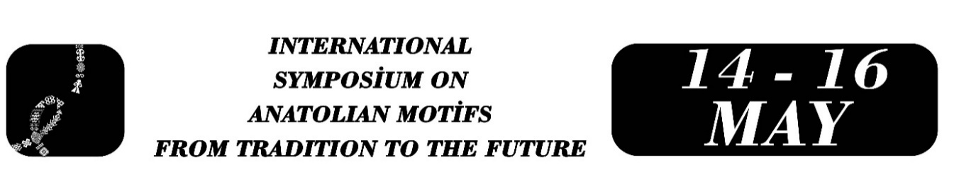

A Visual Examination of the Transmission of Bünyan and Yahyalı Carpet Motifs to Different Handicraft Disciplines in the Workshops of Kayseri Olgunlaşma Institute
Neslihan Toprak
Yeter Hanım Demirtaş
Abstract
In the tradition of Turkish handicrafts, carpet weaving is one of the most established fields that carries social memory through its rich motif repertoire and symbolic language. Kayseri and its surroundings have historically been among the centers of this tradition with Bünyan and Yahyalı carpets; however, changing production conditions have restricted the sustainability of this heritage in the field of traditional weaving. At this point, Olgunlaşma Institutes play a strategic role in the preservation of cultural heritage by transferring the traditional data in their archives to different branches of art. This study aims to examine how Bünyan and Yahyalı carpet motifs preserved in the archive of Kayseri Olgunlaşma Institute are transferred to traditional clothing (bindallı) and ceramic objects produced in the institute’s workshops. The research is based on a qualitative visual analysis method. The sample was determined through criterion-based purposeful sampling among project outputs produced within the institute. In the selection of the sample, two main criteria were taken into account: representing both carpet traditions (Bünyan and Yahyalı) and covering different fields of application (embroidery/clothing and ceramics). Accordingly, eight products (four bindallı garments and four ceramic/accessory items) were selected and comparatively analyzed together with their original carpet patterns and technical drawings. In the analysis, four main criteria were used: fidelity to the source motif, the way the form is adapted to the new surface, changes in composition, and technical characteristics of the application. The findings indicate that the characteristic floral medallions of Bünyan carpets largely preserve their formal integrity in embroidery applications on bindallı, whereas the geometric motifs of Yahyalı carpets are simplified and reinterpreted on ceramic surfaces due to technical constraints. The study reveals, through concrete examples, how the re-production of carpet motifs on different materials contributes to the continuity of cultural heritage.
Keywords: Bünyan carpet, Yahyalı carpet, motif transmission, visual analysis, Kayseri Olgunlaşma Institute

Expert Teacher, Neslihan Toprak, Kayseri Olgunlaşma Enstitüsü, neslihan.toprak@yahoo.com.tr
Headteacher, Yeter Hanım Demirtaş, Kayseri Olgunlaşma Enstitüsü, yeterhanimdemirtas38@gmail.com

