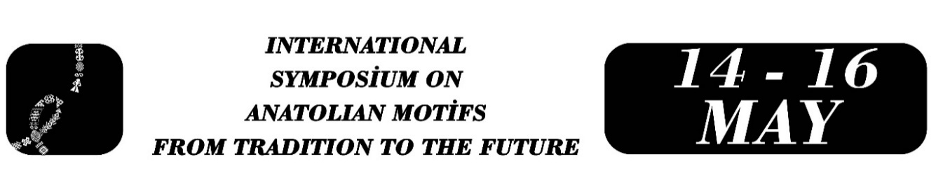

From Cultural Memory to Digital Representation: The Transformation of Motifs in Anatolian Oral Culture in AI-Assisted Texts
Alper YILDIZ
Abstract
This paper aims to examine how traditional motifs in Anatolian oral culture are represented in AI-assisted text generation and to explore the relationship between these modes of representation and cultural memory. The central research question is whether motifs that function as carriers of cultural memory maintain their functional continuity in digital narratives or undergo semantic flattening.
Methodologically, frequently encountered motifs in oral tradition—such as the road, fate, mountain, fire, and animal motifs—were selected. Their functions in proverbs and idioms were comparatively analyzed alongside their representations in short texts generated through controlled prompts in an AI-based text production system. The analysis was conducted according to three main criteria: contextual embeddedness, density of meaning, and normative function.
The findings indicate that in traditional texts, motifs condense social experience, guide behavior, and sustain cultural memory, whereas in AI-generated texts they are predominantly employed to provide recognizability and aesthetic resonance. This suggests a tendency for motifs to become partially detached from their cultural context and to function as narrative templates.
In conclusion, the study approaches the reproduction of traditional motifs by artificial intelligence not as a matter of technical adequacy but as an issue of cultural representation and meaning transmission. The transformation of the relationship between motifs and cultural memory in digital narratives is discussed within the framework of contemporary cultural production.
Keywords: Cultural memory, motif, oral tradition, artificial intelligence, digital narrative.

Research Assistant, Çağ University, Turkish Language and Literature, alperyildiz@cag.edu.tr

