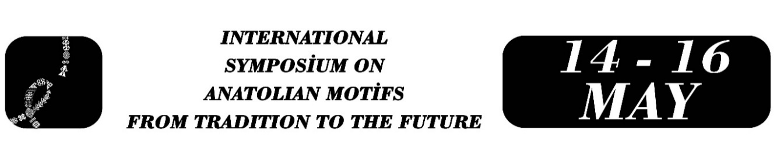

Mirrors and Cosmic Geometry in Anatolian Folk Culture: A Symbolic Interpretation of the Flower of Life Motif
Yılmaz KAVAL

Abstract
In Anatolian culture, mirrors have not been viewed merely as reflective objects since ancient times, but have also been accepted as cultural elements imbued with folk culture and symbolic meanings. This study aims to interpret the ‘flower of life’ motif carved on a wooden mirror in the Tunceli Museum collection using an object-oriented folklore approach. A review of studies on Anatolian mirrors reveals that they are generally limited to aspects of form and function, with insufficient focus on folk culture and symbolic meanings. This study aims to address this deficiency and analyse Anatolian mirrors as objects of folklore. In line with the object-oriented folklore approach, the study will analyse the process of meaning creation in the collective memory of the Anatolian people. In addition to Panofsky's method of ‘iconographic analysis,’ this study draws on Mircea Eliade's concepts of ‘the sacred and the profane’ and his work on symbolic analysis. In this context, the historical context in which the mirror was produced is evaluated alongside the mission it carries in Anatolian folk beliefs and the symbolic meanings it expresses. The study will examine the meanings represented by the ‘flower of life’ motif, accepted as a universal motif, in Anatolian folk culture and beliefs, alongside its cyclical and holistic meanings, and will express the various symbolic functions of the mirror. It has been observed that both the mirror and the life flower motif on it have a rich representational capacity in folk culture in ancient Turkish and Anatolian folk beliefs. This proves that the people of Anatolia reflect and pass on their folk culture from generation to generation not only through oral tradition but also through objects. This study shows that we can also benefit greatly from elements of tangible cultural heritage when explaining Anatolian folklore. In conclusion, this study, based on the motif of the flower of life on a historical mirror in the Tunceli Museum, has interpreted this motif and revealed the place and function of the mirror in Anatolian folk beliefs. Thus, it will contribute to studies that reveal the connections between material culture and folk beliefs. Furthermore, the study will contribute to the reinterpretation of objects in museums within the context of folklore, using this mirror in the Tunceli Museum as an example, and will contribute to future studies.
Keywords: Mirror, Flower of Life motif, cosmic order, material culture, Anatolian folk culture.

Munzur University, Department of Turkish Language and Literature, yilmazkaval@munzur.edu.tr

