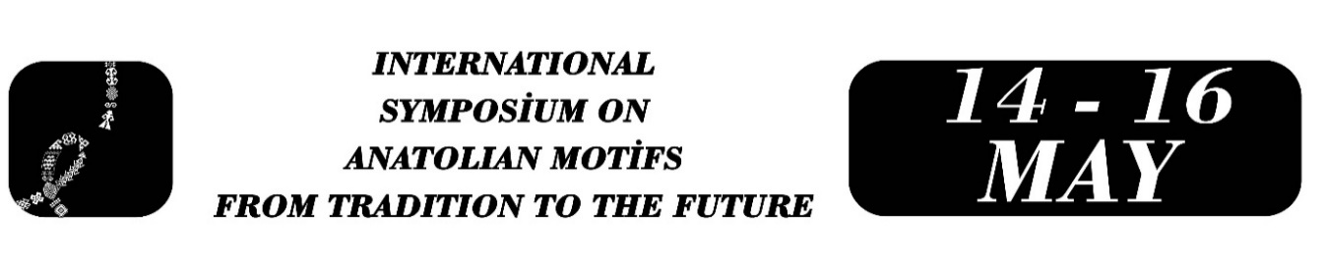

The Image of the Ewer in Ottoman Miniature Art: The Example of Levnî
Seren AKSOY
Abstract
This study examines the ewer depictions frequently represented in the works of Levnî, one of the prominent artists of the Ottoman period, within their cultural context. The sacredness of water in Islamic culture and the artistic representation of the ewer as a vessel mediating this sacredness constitute the main focus of the research.
The aim of the study is to identify the ewer depictions in Levnî’s miniatures, evaluate their contexts of use, and examine how they have been transmitted from Ottoman cultural heritage to the present day.
The research was conducted using qualitative methods, including a literature review and visual analysis. In particular, ewer depictions in guild procession scenes were analyzed through visual and historical data.
The findings reveal that in Levnî’s miniatures, ewers generally appear as valuable gifts presented to the sultan in guild processions and festival scenes. It is observed that the frequently depicted ewers are made of precious metals such as gold and silver. This emphasizes that ewers functioned not only as everyday objects but also as symbols of prestige and respectability. Moreover, in Islamic culture, the symbolic meaning of the ewer is associated with water, cleanliness, and ablution.
Therefore, the ewers depicted in Levnî’s miniatures provide visual insight into water culture, religious rituals, and social hierarchy in Ottoman society. These representations offer significant information about the material culture and belief system of the period.
Keywords: Levnî, miniature art, ewer, Ottoman culture, visual analysis, water symbolism

