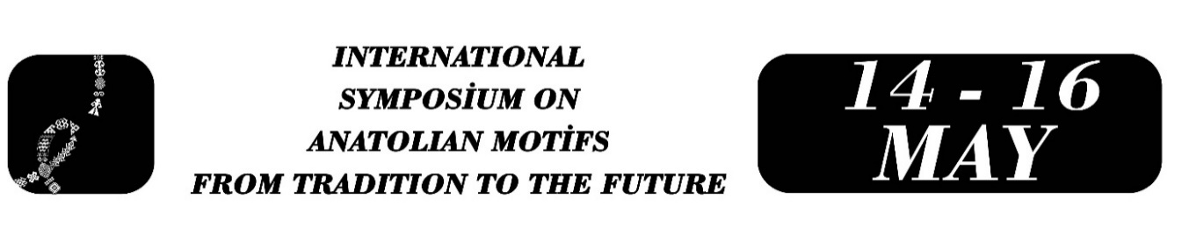

Ebru Art (Marbling) and Mathnawi
Malik Uğur DADAK
Abstract
When examining the manuscript of Mevlânâ Celâleddîn-i Rûmî's work titled Mesnevî-i Ma‘nevî in terms of decorative elements, one of the elements encountered is the art of ebru (marbling). In this context, the subject of the present study is based on six 14th-century manuscripts of the Masnavi that contain examples of marbling on their bindings. One of these manuscripts is preserved at the Berlin Königlichen Bibliothek Number 763, while the remaining five manuscripts are preserved in the archives of three different libraries in Türkiye. Upon examination of the six manuscripts in question, the ebru in the manuscript at Berlin Königlichen Bibliothek Number 763 is a nightingale's nest pattern in shades of Lahore indigo, black, white, green, or gray, applied to the protective pages of the manuscript. The front and back covers of manuscript number Mustafa Con A 259 at the Ankara University, Faculty of Language and History-Geography Library are covered with paper featuring a combed pattern in shades of light yellow, oxide, indigo red, blue, and white, depicting a nightingale's nest marbling motif. The manuscript numbered 7207, located in the Manisa Provincial Public Library, has its back of the front cover and the following page covered with marbled paper in shades of oxide yellow, oxide red, and light blue, featuring a gel-git and shawl pattern. The dust jacket flap of manuscript number 2648 in the same library is covered with shifted/wavy design marbled paper in color of light blue and white. Upon examination of copies numbered 52 and 1113 in the Konya Mevlana Museum it was determined that the back cover of manuscript number 52 is bound with paper featuring a hatip ebru pattern in black tones; while the first and last pages of manuscript number 1113 have a stone pattern in light tons of white, oxide red, and oxide yellow. Indeed, it is observed that the ebru patterns in the Masnavi manuscripts, whose library and inventory information is given above, were generally used in these manuscripts to decorate the protective leaves or book covers.
Keywords: Ebru Art, Masnavi and Ebru Art, Marbling, Mathnawi-i Manavi.

Malik Uğur DADAK, Dicle Üniversitesi, Doğu Dilleri ve Edebiyatları Bölümü Fars Dili ve Edebiyatı Anabilim Dalı, ugurdadak@hotmail.com.

