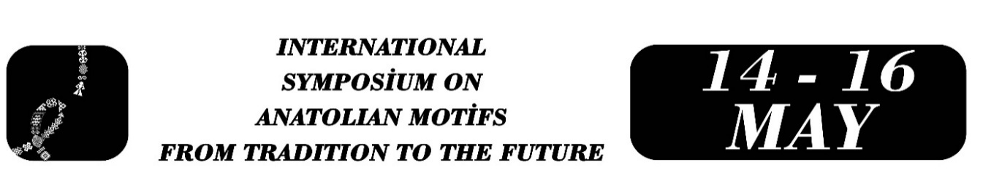

REPRODUCTION OF TRADITIONAL FORMS IN NEW MEDIA ART: “PARIBU ART” FACADE SCREENINGS
Meric Demirci

Abstract
Postmodernism has led to a condition in which reality is displaced by images, as everyday life becomes aestheticized and existence is reshaped around consumer culture. Within this process, local cultural heritage and authentic codes are detached from their historical contexts and transformed into new “image-spaces” through the dynamics of global networks. The eclectic juxtaposition of traditional, modern, and postmodern forms through a logic of pastiche and collage constitutes the foundation of this new visual regime. The building facade interventions that form the focal point of this study convert modern architectural surfaces into dynamic screens, transforming urban space into a vast spectacle arena. In this setting, where lived reality is supplanted by spectacular images, the spatio-temporal compression of late capitalism converges with a continuous 24/7 attention economy. The urban observer is reduced to a consumer perpetually open to stimulation, while traditional craft forms become objects of instant consumption. Methodologically, this study employs the descriptive analysis technique within a qualitative research framework, grounded in a Cultural Theory perspective, to critically examine Paribu Art’s exterior facade projections. Through the case of Paribu Art’s façade displays, the study aims to discuss how traditional forms are reduced to aesthetic images through digital processes and how, within the uninterrupted late-capitalist urban space, the space of spectacle, and the network of the system of objects, they are reproduced solely as markers of consumption. Accordingly, traditional motifs reproduced through digital algorithms and projected onto building facades become merely superficial forms, simulacra that constitute fragments of a vast “system of objects” severed from their roots. In this universe dominated by hyperreality, commodified images are presented for mass consumption exclusively through their sign-value.
Keywords: postmodernism, image, urban space, simulacra, system of objects.

Graduate Student, Meric Demirci, Uskudar University, Media and Cultural, Studies, meeriiicdemirci@gmail.com.

