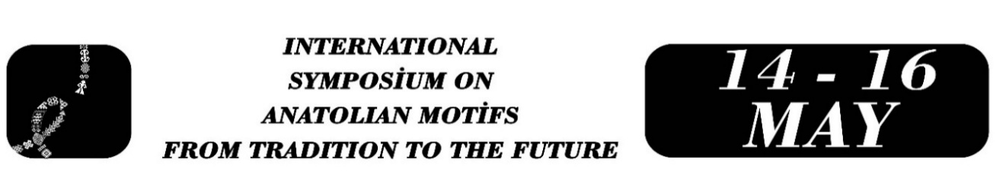

SYMBOLİSM AT THE TABLES WHERE THE TİGRİS AND BOTAN MEET: ANTHROPOLOGİCAL ANALYSİS OF MOTİFS ON KİTCHEN UTENSİLS FROM THE SİİRT ÇATTEPE EXCAVATİONS
Elif BOBUŞ
Gökhan ERTEK
Rıdvan ARSLAN
Özet
This paper examines the symbolic language of kitchenware unearthed during the excavations of Çattepe Mound, located at a strategic point where the Tigris River and Botan Stream intersect in Siirt, serving as one of the significant ancient port cities of Mesopotamia. Ceramics, glazed and unglazed terracotta lamps, Khabur painted vessels, and metal objects identified in the mound—bearing traces from the Prehistoric Period to the Middle Ages—reflect not only the dining practices of the era but also its deep-rooted cultural memory. Within the scope of this research, the relationship between the geometric lines, grooves, and incised motifs found on Çattepe artifacts and the rituals of "abundance" offered by the rivers, as well as the "hospitality" resulting from being a frequent stop for caravans, is analyzed through an anthropological perspective. The study discusses how this ancient visual language, inscribed on clay and metal, shaped social status, belief systems, and sharing networks around the table. While deciphering the socio-cultural meanings behind these millennia-old local motifs, the study focuses on how this heritage of our centuries-old culinary culture can be sustained in contemporary gastronomy and experience design. These motifs, carried from tradition to the future, demonstrate that local culinary culture is not merely a form of consumption, but a profound medium of communication.
Anahtar Kelimeler: Çattepe Mound, Siirt Culinary Culture, Archaeological Ceramics, Motif Analysis, Table Symbolism, Cultural Memory.

Director of Siirt Maturation Institute, Elif BOBUŞ, Gazi University, Department of Child Development Education, ipekelifekinci@gmail.com
Art History Master Instructor at Siirt Maturation Institute, Gökhan ERTEK, Van Yüzüncü Yıl University, State Conservatory, olgunlasmasiirt@gmail.com
Visual Arts Teacher at Siirt Maturation Institute, Rıdvan ARSLAN, Anadolu University, Department of Fine Arts Education, rdvncnplt1@gmail.com

