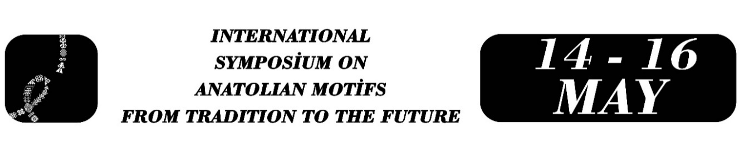

Body Folklore, Myth and Identity: Turkish Folk Art Motifs Used in Tattoos

Emine ÇAKIR

Abstract
Body folklore is an approach that views the human body as a cultural narrative, symbol, expression, and memory space. This study, which examines tattooing as a representation and identity space of cultural memory, aims to determine the reasons for choosing motifs from Turkish mythology for tattoos. Semi-structured interviews were conducted with individuals who had motifs related to Turkish mythology tattooed on their bodies. This study, which employed a qualitative research design, was conducted in Ankara in 2026. The focus is on those who get tattoos rather than those who tattoo. The reasons why those who get tattoos prefer motifs related to Turkish mythology and whether they know the cultural codes of these motifs, and whether tattooing is an aesthetic choice or a cultural narrative form at the intersection of individual memory and collective memory, have been discussed. Furthermore, the study sought to answer how motifs found in traditional handicrafts common in Anatolia, such as kilims, carpets, tiles, embroidery, and wood carving, are transferred to tattoo designs. The symbolic meanings of the motifs identified in the study (fertility, protection, belonging, power, continuity, etc.) were analyzed, and the ways in which these symbols are reproduced on the modern body surface were evaluated in relation to the concepts of identity and belonging. It has been observed that informants particularly prefer visuals such as the grey wolf, dragon, eagle, and shaman drum as tattoos on their bodies. It has been determined that informants who choose to have written and visual data representing Turkish mythology tattooed on their bodies draw strength from these tattoos, believe that the tattoos protect them, establish a connection between their destiny and fate and the tattoos, and create a sense of belonging with Turkish identity. The reinterpretation of traditional motifs through tattoos has revealed that cultural heritage is not static but rather a living structure that evolves. It has also been understood that the art of tattooing has become a practice of identity construction for individuals. In this context, tattoos can be considered both a means of self-expression and a physical archive of cultural memory. The use of traditional handicraft motifs in tattoos creates an aesthetic and symbolic link between the past and the present and enables the reproduction of cultural memory through the body.

Keywords: Body folklore, visual culture, Turkish mythology, handicraft motifs, tattoo.

Doç. Dr. Emine Çakır, Ankara Hacı Bayram Veli Üniversitesi, Edebiyat Fakültesi, Türk Halk Bilimi Bölümü, eminecakir.thb@gmail.com.

