

INTEGRATION OF ANATOLIAN MOTIFS INTO SMART AND FUNCTIONAL TEXTILES:
Hidayet Bağcı
Abstract
This study addresses the integration of Anatolian traditional motifs into smart and functional textile surfaces at the intersection of art/design and engineering disciplines. Anatolian motifs have historically been present on textile surfaces not only as an aesthetic element but also as carriers of cultural memory and symbolic narratives. Today, smart and functional textiles represent a new production paradigm in the textile field, as structures that can perceive environmental stimuli, interact with the user, and offer advanced performance features.
In this context, the study discusses how the symbolic and visual structures of traditional motifs can be integrated with conductive yarns, sensor systems, functional coatings, and digital embroidery technologies. Motifs are considered not only as decorative surface elements but also as a design input that carries both meaning and function, guiding the placement of functional components. The combined evaluation of artistic and engineering perspectives enables the sustainable reinterpretation of cultural heritage through contemporary textile technologies.
Keywords: Anatolian motifs, smart textiles, functional textiles, interdisciplinary design, cultural heritage, textile engineering.
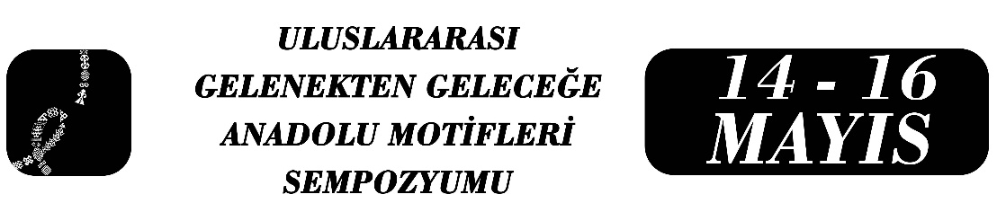
ANADOLU MOTİFLERİNİN AKILLI VE FONKSİYONEL TEKSTİLLERE ENTEGRASYONU:

Özet
Bu çalışma, Anadolu geleneksel motiflerinin akıllı ve fonksiyonel tekstil yüzeylerine entegrasyonunu, sanat/tasarım ve mühendislik disiplinlerinin kesişiminde ele almaktadır. Anadolu motifleri tarih boyunca yalnızca estetik bir unsur değil, kültürel hafıza ve sembolik anlatı taşıyıcısı olarak tekstil yüzeylerinde varlık göstermiştir. Günümüzde ise akıllı ve fonksiyonel tekstiller; çevresel uyarıları algılayabilen, kullanıcıyla etkileşim kurabilen ve gelişmiş performans özellikleri sunan yapılar olarak tekstil alanında yeni bir üretim paradigması ortaya koymaktadır.
Bu bağlamda çalışma, geleneksel motiflerin sembolik ve görsel yapılarının; iletken iplikler, sensör sistemleri, fonksiyonel kaplamalar ve dijital nakış teknolojileriyle nasıl bütünleştirilebileceğini tartışmaktadır. Motifler, yalnızca dekoratif bir yüzey unsuru olarak değil; fonksiyonel bileşenlerin yerleşimini yönlendiren, anlam ve işlevi birlikte taşıyan bir tasarım girdisi olarak ele alınmaktadır. Sanat ve mühendislik perspektiflerinin birlikte değerlendirilmesi, kültürel mirasın çağdaş tekstil teknolojileriyle sürdürülebilir biçimde yeniden yorumlanmasına olanak tanımaktadır.

Anahtar Kelimeler: Anadolu Motifleri, Akıllı Tekstiller, Fonksiyonel Tekstiller, Disiplinlerarası Tasarım, Kültürel Miras, Tekstil Mühendisliği.

1. Introduction
Textiles have been an important area of production throughout history, reflecting both the functional and cultural dimensions of human life. In Anatolia, the motifs used on woven and embroidered surfaces have developed as visual representations of beliefs, nature, social structure, and individual experiences (Ögel, 2014). These motifs have often existed within an anonymous production tradition and have been passed down from generation to generation through oral culture.
Today, the textile field is undergoing a transformation under the influence of materials science, electronics, and digital production technologies. Smart and functional textiles transform the textile surface from a passive carrier into an active, interactive, and multifunctional interface (Tao, 2001). This transformation enables traditional motifs to be re-related to contemporary technology.
This study addresses the integration of Anatolian motifs into smart and functional textile systems as a common production area for the disciplines of art/design and engineering.
2. Anatolian Motifs from an Artistic and Cultural Perspective
Anatolian motifs are visual structures with high symbolic expressive power. Motifs contain cultural codes representing concepts such as abundance, protection, fertility, belonging, and the cycle of nature (Gürsoy, 2015). In this sense, the motif is not merely a formal repetition but a narrative element that carries meaning.
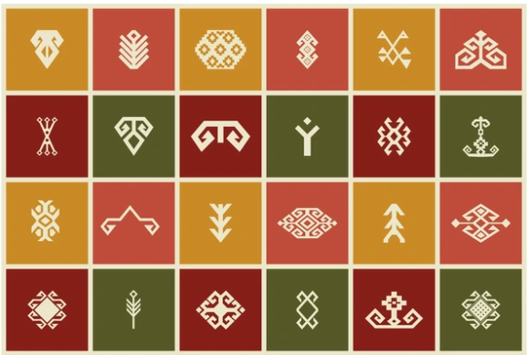
Figure 1. Anatolian Motifs

The arrangement of motifs on the textile surface, the rhythm of repetition, and the relationship established with the spaces create a visual narrative language. Similar to the function of literary images within a text, this structure produces multiple meanings through the relationship established with the viewer (Barthes, 1977). From an art and design perspective, motifs can be evaluated as a narrative organization constructed on the surface.
3. Smart and Functional Textiles from an Engineering Perspective
Smart textiles are defined as textile systems that can sense environmental stimuli and respond to them (Tao, 2001). Functional textiles, on the other hand, are textile structures with performance characteristics such as conductivity, thermal regulation, antibacterial effects, UV protection, and moisture management (Stoppa & Chiolerio, 2014).
Conductive yarns, metal-coated fibers, carbon-based nanomaterials, phase-changing materials, and sensor technologies are used in the development of these systems (Cherenack & van Pieterson, 2012). From an engineering perspective, the textile surface provides a suitable platform for electronic components due to its mechanical flexibility and large surface area.
4. Integration Process: Motifs Meet Function
The integration of Anatolian motifs into smart textiles requires considering aesthetics and function together. In this process, motifs can be approached not only as decorative elements on the surface but also as a structure that organizes the placement of functional components.
Motif lines created with conductive threads can enable electrical circuits to be arranged aesthetically on the surface (Dias, 2015). Integrating sensors with motif repetitions allows for the design of textile surfaces that interact with the user. This approach makes motifs a visible part of the technological function.
5. Hybrid Design Approaches and Example Applications
The hybrid design approach refers to a production process in which the disciplines of art and engineering contribute equally. The geometric structure of Anatolian motifs provides a systematic template for the arrangement of sensor networks and conductive paths.
Motifs created with thermochromic or photochromic paints can change color depending on environmental conditions, creating interactive surfaces (Mattila, 2006). Such applications add a new narrative layer to motifs, transforming cultural symbols into a dynamic field of experience.
6. Discussion
This approach, which addresses the disciplines of art and engineering together, allows for the reproduction of cultural heritage with contemporary technology. In this context, Anatolian motifs are not considered a static element of the past, but rather a living design language that can adapt to technological developments.
Interdisciplinary production enhances both the intellectual and technical potential of textiles, establishing a sustainable link between the traditional and the innovative (Ingold, 2013).
7. Conclusion
This study has addressed the integration of Anatolian motifs into smart and functional textiles from an interdisciplinary perspective. The art/design perspective highlights the cultural and narrative value of the motifs, while the engineering approach explains their potential for integration with technological systems.
In conclusion, Anatolian motifs can be considered hybrid design elements that preserve cultural memory but gain new functions through contemporary textile technologies. This approach proposes a sustainable textile language that bridges tradition and the future.
References
Assmann, J. (2011). Cultural memory and early civilization. Cambridge University Press.
Barthes, R. (1977). Image, music, text. Hill and Wang.
Cherenack, K., & van Pieterson, L. (2012). Smart textiles: Challenges and opportunities. Journal of Applied Physics, 112(9), 091301.
Dias, T. (2015). Electronic textiles: Smart fabrics and wearable technology. Woodhead Publishing.
Gürsoy, S. (2015). Anadolu dokumalarında motif ve anlam. Kültür ve Turizm Bakanlığı Yayınları.
Ingold, T. (2013). Making: Anthropology, archaeology, art and architecture. Routledge.
Mattila, H. R. (2006). Intelligent textiles and clothing. Woodhead Publishing.
Ögel, B. (2014). Türk kültür tarihine giriş. Türk Tarih Kurumu Yayınları.
Stoppa, M., & Chiolerio, A. (2014). Wearable electronics and smart textiles. Sensors, 14(7), 11957–11992.
Tao, X. (2001). Smart fibres, fabrics and clothing. Woodhead Publishing.

