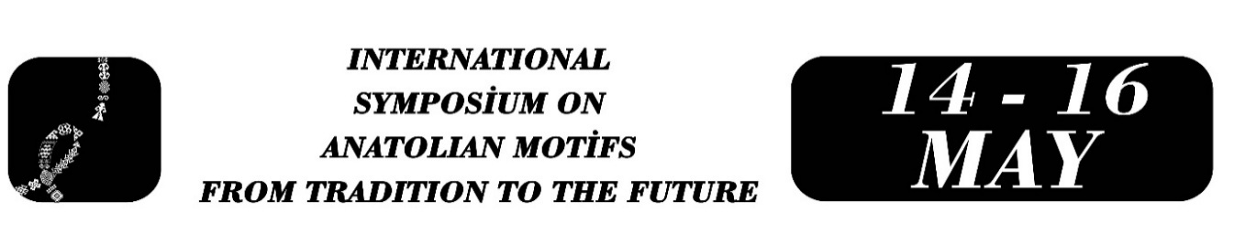

THE WORLD OF WOMEN'S EMOTIONS AND DESIRES IN ANATOLIAN MOTIFS
Kadriye PATAN
Abstract
Anatolian motifs can be regarded not only as an aesthetic decorative element but also as a symbolic language reflecting women's emotional and desire-filled world. Based on Stith Thompson's definition of motif, the concept of motif—accepted as the smallest unit of meaning carrying continuity and strikingness in folk narratives—is seen to serve a similar function in Anatolian weaving and textile arts. The motifs found in kilims, carpets, embroidery, and needlework are symbolic expressions that are passed down from generation to generation through repetition, reflecting specific cultural codes and the belief systems of societies. The weaving tradition in Anatolia, largely shaped by women's labor, creates a space where women both preserve cultural memory and indirectly express their individual experiences, feelings, thoughts, and desires. Women, whose ability to directly express their feelings and desires is limited within a patriarchal social structure, have created an alternative means of expression for themselves through motifs. In this context, motifs function as a narrative tool that symbolically conveys women's suppressed feelings, expectations, longings, and desires. In this study, the motifs of the hairband, chest, handkerchief, and waterway will be examined as examples of motifs that express women's emotional world in this context. These motifs have been analyzed within the framework of themes such as female identity, the marriage process, the concept of fertility, intergenerational continuity, and the sense of belonging. Thus, it has been revealed that motifs are not merely decorative elements created for aesthetic purposes, but also contain layers of meaning that reflect women's active position in cultural production, their forms of silent resistance, and their inner worlds. This study aims to reinterpret Anatolian motifs through a women-centered perspective.
Keywords: Anatolian Motifs 1, Cultural Memory 2, Gender 3, Female Identity 4, Symbolic Expression 5

Kadriye PATAN, kadriyepatan@gmail.com.

