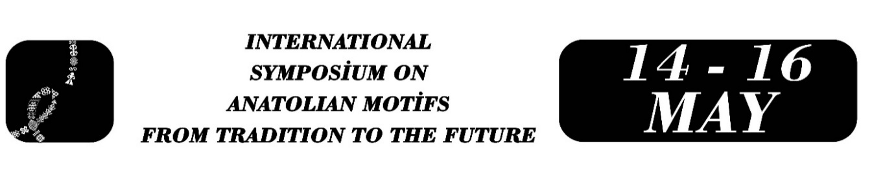

The Influence of the Curvilinear Branch Style in the Tiles of Kubad Abad Palace on the Development of the Saz Style: A Historical, Stylistic, and Archaeological Analysis
Ayşe ÖZBEK PAMUK

Abstract
This study aims to examine the contribution of the curvilinear branch style observed in the tiles of Kubad Abad Palace to the morphological development of the saz style, which was refined during the 16th century Ottoman classical period by illuminators such as Şahkulu, Veli Can, and Kara Memi. Within the scope of the research, compositions featuring lion, dog, wolf, siren, bird, and human figures found on 13th-century Seljuk palace tiles were evaluated stylistically based on the findings from the Great Palace and Small Palace excavations. The study employs a qualitative comparative analysis method, investigating inter-stylistic continuity through elements such as linear patterning, flow of curvature, compositional arrangement, rhythm, color–contour relationship, and iconographic structure.
The findings reveal that the curvilinear branch style in Seljuk tiles produces a dynamic surface conception grounded in spiral movement, dense vegetal interlacing, and the fusion of figures with plant motifs. In certain examples, the elongation and thinning of vegetal curves, the sprouts approaching a dagger-shaped leaf form, the more deliberate organization of compositional voids, and the controlled rhythmic flow of lines indicate that early forms of the saz style had already begun to take shape during the Seljuk period. This transitional linear approach points to an intermediate stylistic phase that can be defined in the literature as proto-saz.
The study demonstrates that while the tiles of Kubad Abad reflect the curvilinear branch style in its most mature form, they simultaneously represent an early, transitional, and continuous link in the linear transformation that later formed the basis of the Ottoman saz style. In this respect, the Kubad Abad tiles constitute not only a significant reference point for understanding stylistic evolution in Seljuk art but also a key source for the development of classical Ottoman ornamental aesthetics.
Keywords: Curvilinear Branch Style; Saz Style; Kubad Abad Palace; Seljuk Tile Art

Lecturer Dr. Ayşe Özbek Pamuk, Zonguldak Bülent Ecevit University, Devrek Vocational School, ayseozbekk@icloud.com.

