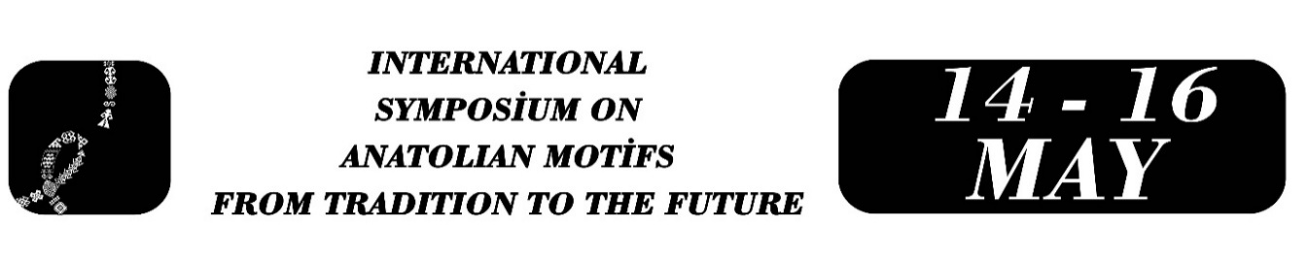

ESOTERIC SYMBOLISM IN ANATOLIAN CERAMIC ART: THE TRUTH BEYOND FORM
Ebru ATICI

Abstract
Traditional Anatolian ceramic art has served as a symbolic repository of memory throughout history, conveying cosmological conceptions, human understanding of evolution, and metaphysical beliefs about existence through a visual language, beyond merely being an aesthetic element adorning architecture. This paper aims to examine the esoteric (deep/meaningful) layers of motifs in ceramic art beyond their apparent (formal) characteristics from an “esoteric symbolism” perspective.
Within the scope of this study, fundamental motifs frequently encountered in the tile tradition that developed during the Anatolian Seljuk State and Ottoman Empire periods, such as the Tree of Life, Rumi, and geometric interlacing (girih), are reinterpreted within the framework of ancient esoteric teachings and symbolic thought systems. Furthermore, the tile production process—kneading clay with water, firing it in a kiln, and glazing it to achieve its final form—is evaluated in parallel with the alchemical tradition's metaphor of raw material being purified and reaching perfection. In this context, the production practice is interpreted as a model of symbolic transformation and inner purification, beyond being a material craft process.
In the contemporary design environment, where digitalization is accelerating and symbolic depth is becoming increasingly superficial, how this multi-layered world of meaning inherent in ceramic art can be integrated into today's design language is also an important dimension of the discussion. The study examines traditional motifs not only as decorative elements but also as carriers of meaning-making potential. The art of ceramics is positioned not only as an aesthetic field of production but also as a symbolic language of communication between the human inner world and the universal order. This approach highlights the necessity of transmitting traditional motifs to future generations not merely as a formal legacy but as a multi-layered map of meaning.
Keywords: Tile Art, Esotericism, Symbolism, Anatolian Seljuk, Ottoman, Evolution, Traditional Design.

Assistant Professor, Ebru ATICI, Ankara University of Music and Fine Arts, Traditional Handicrafts Program, ebru.atici@mgu.edu.tr .

