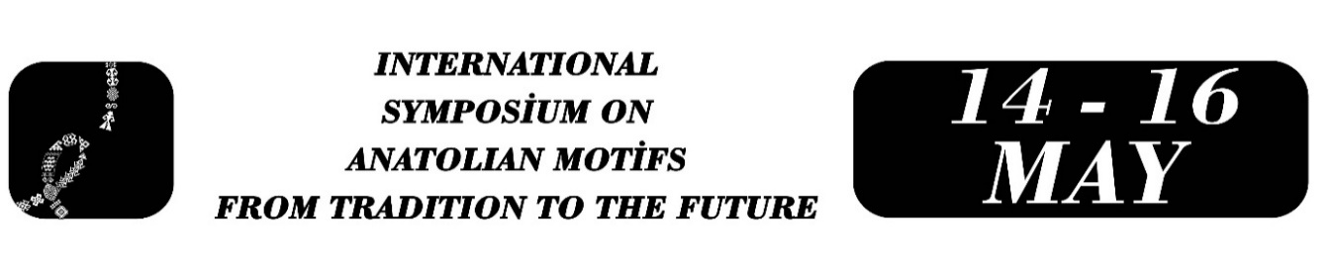

THE TRANSITION FROM TRADITIONAL TO MODERN JEWELRY AND THE PLACE OF MOTIFS IN TURKISH CULTURE
Eda Yılmaz
Gamze Koca
Abstract
This study examines the changes and transformations in traditional Turkish jewelry, which has a very long history, during its transition to modern jewelry, and the meaning of many cultural elements and motifs it carries from the past within this change and transformation. Jewelry and motifs are not only aesthetic objects but also play a role as indicators of belief and culture, social status, and personality. In the modern era, it is seen that our cultural elements are reinterpreted and adapted to life under the name of contemporary designs. While motifs in the traditional understanding of jewelry were seen as status symbols, marriage symbols, or protective objects, indicating a more general meaning, in today's modern jewelry, each motif is reduced to a more specific form, becoming an aesthetic element, and this aesthetic element sometimes carries superficial and sometimes profound meanings. When examined from the perspective of cultural identity, it is seen that jewelry can carry different forms of meaning and value when compared from the past to the present. Especially when examining the past and present, filigree art, Ottoman-era palace jewelry, and contemporary Anatolian bridal jewelry are of importance in this transition. The study will analyze the changes in traditional and modern jewelry, the meanings of motifs, and their transformations. This will allow us to trace the roles that jewelry and the motifs that give it its identity play in terms of our cultural values, as well as the evolution of its designs.
Keywords: Change and transformation, tradition, culture, motif, jewelry

Eda Yılmaz, Mersin University, Turkish Language and Literature Master's Program, edaay.lmaaz5@gmail.com.
Gamze Koca, University, Turkish Language and Literature Master's Program, gamzekocag27@gmail.com.

