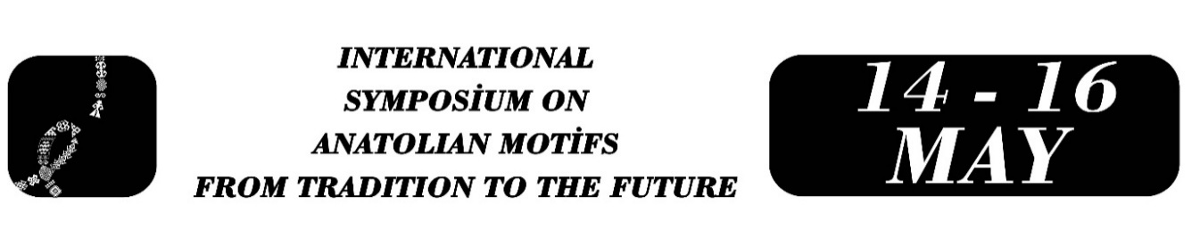

Cultural Transmission and Continuity at the Level of Meaning in Weaving Motifs in Tarsus
Emine Bağcı
Abstract
Anatolian weaving motifs continue to exist as carriers of collective memory and cultural identity. This study aims to examine the process of cultural transmission and continuity at the level of meaning of widely used weaving motifs in Tarsus within the context of circulation. Based on preliminary interviews, the study discusses how the symbolic meanings of motifs are maintained as they move from the sphere of production into the sphere of commercial circulation.
A qualitative research approach has been adopted, and preliminary interviews conducted with two weaving sellers operating in Tarsus have been analyzed. It has been observed that sellers obtain woven products (such as saddlebags, rugs, socks, and printed textiles) from local producers and offer them for circulation in their shops. Through conversations with motif producers, sellers learn the meanings associated with motifs such as elibelinde (a stylized female figure symbolizing fertility), koç (ram), and bıtırak (burr), as well as göz (eye) and yıldız (star) motifs, and consciously transfer this knowledge into the sales process. Customers, in turn, demand these motifs with awareness of their meanings, and in some cases, specific motifs are deliberately preferred. Thus, the process involves not only material circulation but also the transmission of symbolic meaning.
During the fieldwork phase, semi-structured interviews, field observations, and visual documentation techniques will be employed. The findings indicate that motifs such as elibelinde (a stylized female figure symbolizing fertility), koç (ram) and bıtırak (burr) stand out in customer demand and demonstrate continuity at the level of meaning within contemporary circulation processes. It is also stated that these motifs are knowingly demanded within institutional production processes. These findings show that motifs are not consumed merely as decorative elements; rather, cultural transmission is sustained through circulation within the producer–seller–consumer relationship.
Keywords: weaving motifs, cultural transmission, cultural heritage, continuity at the level of meaning, Tarsus

Emine Bağcı, Mersin University, Institute of Social Sciences, Department of Turkish Language and Literature, Mersin/Turkey, bagciemine@gmail.com

